Assignment 1
- Create a new database called student_management.
test> use student_management
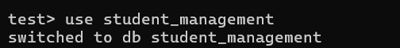

- Create a collection called students in the student_management database.
student_management>db.createCollection("students")
- Insert at least five student records into the students collection. Each record should have the following fields:
- student_id (integer)
- name (string)
- age (integer)
- department (string)
- courses (array of strings)
- grade (string)
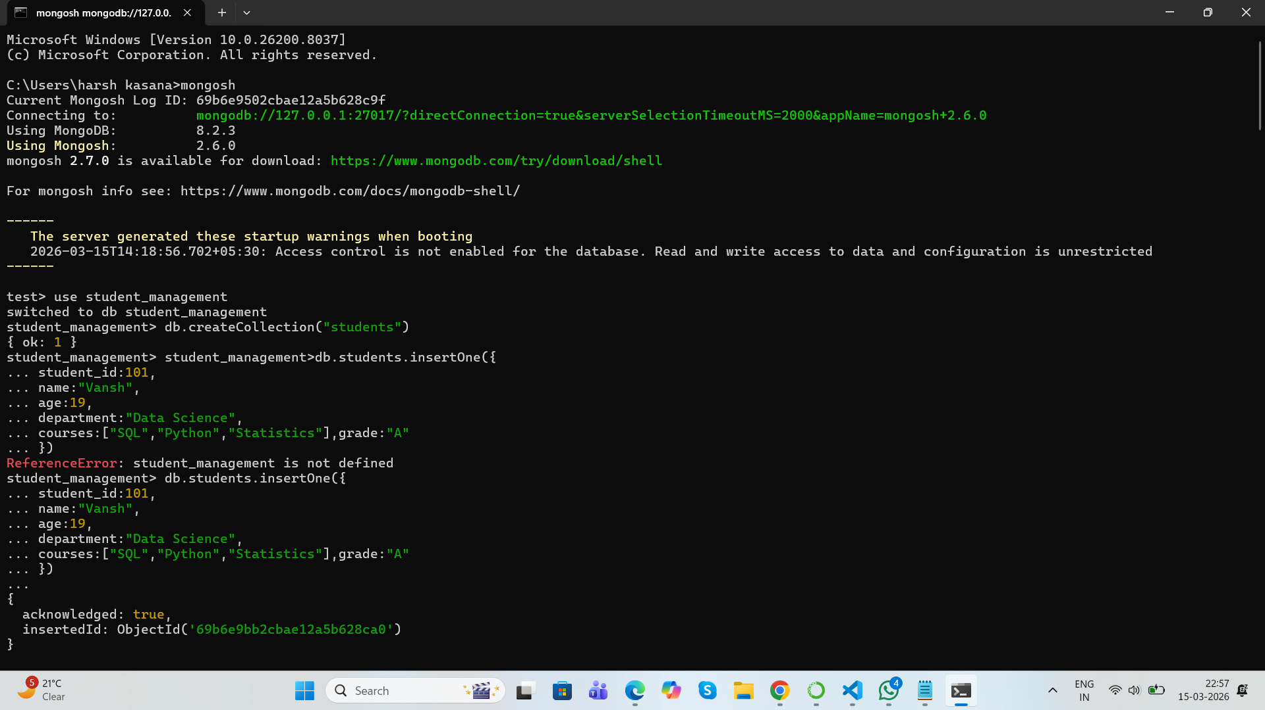

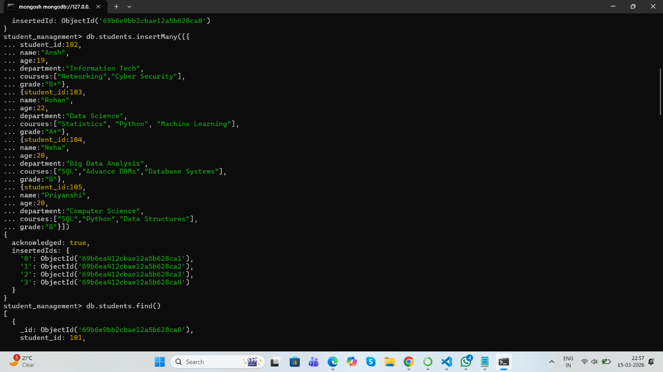

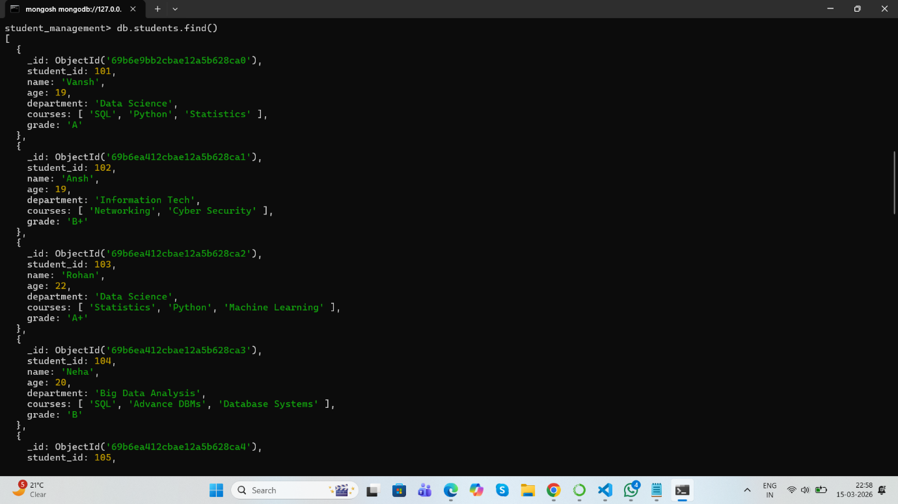

4.Query the Collection:
Write queries to perform the following tasks:
- Retrieve all students who are in the "Computer Science" department.
student_management> db.students.find({department:"Computer Science"})
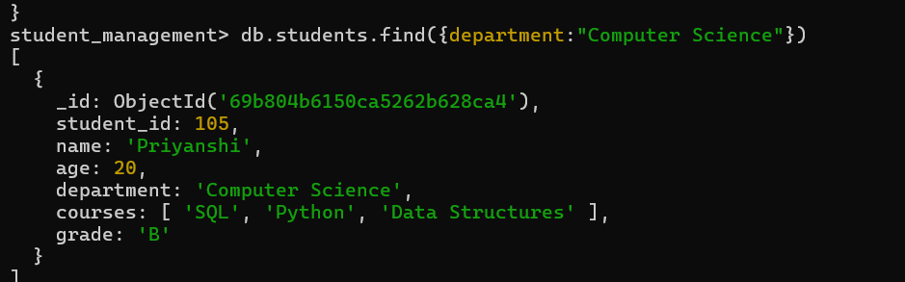

- Retrieve students who have an age greater than 21.
student_management>db.students.find({age:{$gt:21}})
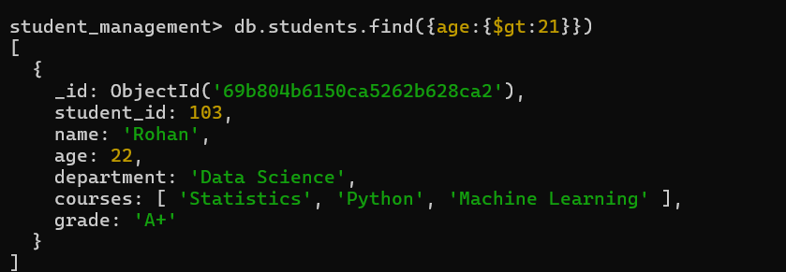

- Retrieve students who are taking the "Database Systems" course.
student_management>db.students.find({courses:"Database Systems"})
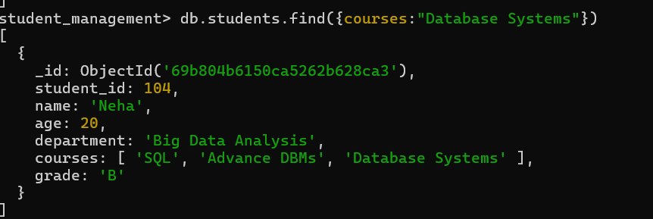

- Retrieve students with a grade of "A".
student_management>db.students.find({grade:"A"})
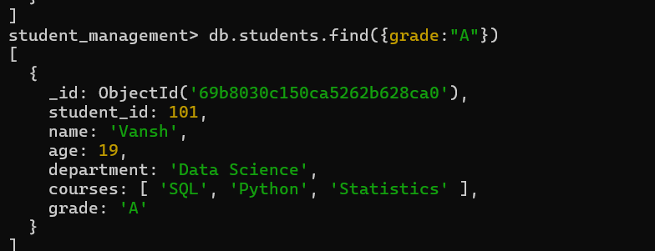

- Update Documents:
- Update the age of a student with student_id 101 to 21.
student_management>db.students.updateOne({student_id:101},{$set:{age:21}})
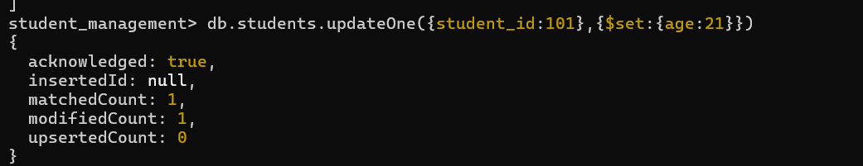
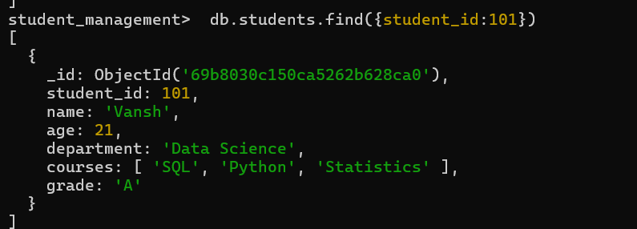
- Add a new course, "Machine Learning", to the courses array for students in the "Computer Science" department.
student_management>db.students.updateMany({department:"ComputerScience"},{$addToSet:{courses:["Machine Learning"] } } )
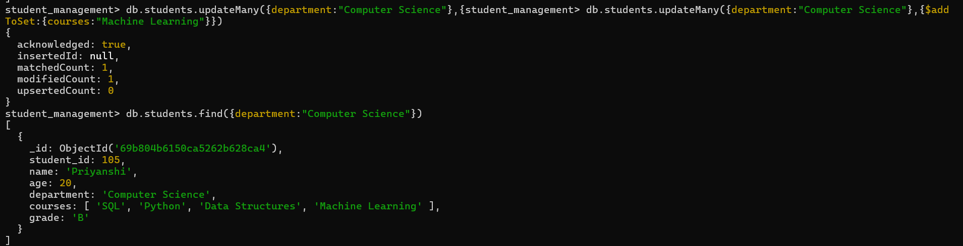

- Delete Documents:
- Delete a student record with student_id 105.
student_management>db.students.deleteOne({student_id:105})

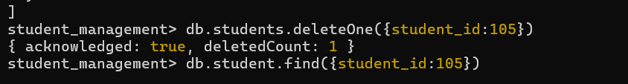

- Delete all students who have a grade lower than "C".
student_management>db.students.deleteMany({grade:{$gt:"C"}})

